**1. ADMINISTRATIVE**

Project title:

Projecting climate change effects on aspen distribution and productivity in the central and northern Rockies by coupling hydrological and landscape-disturbance models

Principal Investigators:

Douglas J. Shinneman, PhD, Research Fire Ecologist  
USGS Forest and Rangeland Ecosystem Science Center  
Snake River Field Station, 970 Lusk St., Boise, ID 83706  
Phone: (208) 426-5206; email dshinneman@usgs.gov

Timothy E. Link, PhD, Professor of Hydrology

University of Idaho

College of Natural Resources

875 Perimeter Drive MS 1133

Moscow, ID 83844-1133

Additional team members: Kathleen Kavanagh (Texas A&M University); Eva Strand (University of Idaho); Susan McIlroy (U.S. Geological Survey); Scott Powell (Montana State University); Robert Scheller (Portland State University); John Campbell (Oregon State University); Daniel Marks, Mark Seyfried, and Adam Winstral (Agricultural Research Service, Northwest Watershed Research Center)

Agreement number: G14AP00153

Date of report: April 3, 2017 (for period covering June 25, 2016-April 3, 2017)

**2. PUBLIC SUMMARY**

**3. TEHCNICAL SUMMARY**

**4. PURPOSE AND OBJECTIVES**

Quaking aspen (*Populus tremuloides*) is a keystone species that is thought to be in decline across much of the western United States due to fire suppression, severe drought, herbivory, conifer competition, and mortality from disease and insects (XXXX). As the only deciduous tree species with substantial extent in the western mountains, aspen communities are considered “biological hotspots” (Chong et al. 2001), and their continued decline is expected to result in cascading losses of animal and plant species in the region (Campbell and Bartos 2001). Aspen is also economically and socially important in the western U.S., producing high quality forage for livestock and wildlife (Mueggler 1988), drawing tourists, and improving local economies (McCool 2001). Aspen locales are also often sources for streamflow generation, and aspen decline coupled with climate warming and changing precipitation regimes will alter water balance dynamics. For these reasons, land managers have put a high priority on aspen conservation and restoration. However, understanding how climate change will affect aspen communities over time will be critical to their future management and will improve chances for successful restoration.

In general, plant species and natural communities are expected to shift their distributions over time as climate change alters plant-water relationships (Lutz et al. 2010, Crimmins et al. 2011). However, climate change has already influenced aspen forest succession and productivity through drought- and heat-induced disturbance events, including sudden aspen dieback (SAD; XXXX). Such events may be harbingers of future decline in aspen populations, and some climate-change predictions suggest that within 50 years approximately 40% of western aspen stands will no longer have a suitable climate (Rehfeldt et al. 2009). However, fundamental questions remain about the linkages between climate and biophysical causal mechanisms driving such forest mortality events (Allen et al. 2010). This critical knowledge gap makes it difficult to estimate the spatiotemporal extent and productivity of future forests. In particular, it is not clear how specific climate change patterns (e.g., diminishing snowpack) and altered disturbance regimes (e.g., fire) will interact to influence rates and patterns of ecological change in aspen, and how that change will affect critical ecosystem services (e.g., streamflow).

There are several lines of evidence that indicate that the moisture subsidy from localized snow redistribution may be essential to aspen productivity and survival in semi-arid or seasonally-arid ecosystems. First, aspen is not drought-tolerant (Lieffers et al. 2001) and relies on adequate soil moisture to remain productive throughout the growing season. Thus, annual changes in the timing and amount of precipitation could potentially lead to large changes in aspen productivity. Second, snow redistribution in complex terrain leads to spatiotemporal variations in water input to soils, as snowdrifts increase effective precipitation in leeward areas and reduce precipitation on wind-scoured ridgetops (Winstral and Marks 2002). Third, plants located below large snowdrifts benefit from snow melt since soil moisture remains elevated into the growing season (Oberbauer and Billings 1981, Seyfried et al. 2009). Finally, current distributions of stands predisposed to drought are predominately located at low elevations with south-southwestern aspects (Worrall et al. 2008; 2010), where a shift from a snow to a rain dominated regime (Nayak et al. 2010) and subsequent loss of moisture subsidies are likely.

Fire is another process that generates critical biophysical variation at local scales that influences aspen distribution and persistence. Most aspen communities are considered fire-dependent and seral to conifers, although some stands may be stable without fire (Strand et al. 2009, Shinneman et al. 2013, Shinneman and McIlroy in prep.). When fire kills overstory trees, it stimulates vigorous aspen resprouting. In the absence of fire, conifer species can replace aging aspen communities over time. Indeed, more fire caused by climate change could prove detrimental to some forest species (e.g. subalpine fir) while at least temporarily benefitting fire-adapted species, such as aspen (Yang et al. 2015). However, other modeled projections of decreased fire rotation, warming temperatures, and shifting precipitation patterns under climate change in the region suggest that some forest types might shift upward in elevation, and some forested areas may convert to non-forest communities (Westerling et al. 2011). Post-fire aspen regeneration response may vary due to factors such as moisture variability from snow, pre-fire forest condition, browsing of young trees, and environment (Hessl and Graumlich 2002). Developing a clear understanding of fire, climate, and successional interactions under climate change is critical for long-term conservation of aspen communities.

Shifts from snow to rain-dominated precipitation regimes often results in earlier streamflows, but may either increase or decrease runoff depending on precipitation timing relative to timing of evaporative demand (Chauvin et al., 2011). Where tree mortality and a change of dominant land cover occurs (e.g., from drought), hydrologic yield can increase if vegetative demand due to mortality declines more than the increased evaporative demand driven by climate. The opposite can also occur, depending on vegetation and climate characteristics, causing streamflows to shift from perennial to intermittent. Altered conditions will affect irrigators that depend on small streams. Thus, a better understanding of how available water resources will change under future land cover and climate regimes will enable the development of measures to enhance the resilience of systems on which their livelihood depends (e.g., developing small reservoirs).

To our knowledge, there are no studies specifically investigating the interactive effects of altered fire and soil-moisture regimes on aspen under climate change and the concomitant alteration of water-balance dynamics. Actionable science is urgently needed by land managers to both prioritize the most effective areas for aspen protection and restoration, and to inform strategies for future water resources management. Unfortunately, projections of future aspen distribution are challenged by a lack of understanding of the linkages between key biophysical drivers and the causal mechanisms controlling the productivity and extent of aspen. If fire becomes more frequent under climate change, it is possible that aspen could prosper in areas where soil-moisture remains adequate, but fire could also significantly hasten aspen’s decline where essential soil moisture subsidies are lost. Under this latter scenario, consequences would include impoverished regional biodiversity and altered ecosystem services, especially water resources.

We examined these dynamics in aspen stands of the central and northern Rockies (CNR) are generally small, scattered, and isolated on the landscape, but are occasionally locally abundant. The relative rarity of aspen communities in the CNR makes them both highly valuable to maintaining biodiversity and highly vulnerable to degradation and loss. Although recent aspen mortality has been potentially less severe in the northern Rockies compared to other parts of the western U.S. (Steed and Kearns 2010), aspen decline has been pronounced in parts of the central Rockies (Romme et al. 1995), and recent bioclimatic models suggest that aspen may nearly disappear from the CNR under most climate change scenarios by 2090 (Rehfeldt et al. 2009). Much of the CNR is characterized by a winter-dominated precipitation regime, in which snowfall subsidizes growing-season soil moisture that is critical for establishment and growth of aspen. A loss or redistribution of this moisture subsidy due to climate change could be detrimental to aspen persistence in the CNR, as evidenced by recent, drought-induced dieback events throughout the western U.S and Canada (Anderegg et al. 2013, Hogg et al. 2008). Wildfire is also an important process in the CNR. As an early-seral species, fire favors aspen persistence in conifer-dominated landscapes, and fire exclusion is considered another primary cause of aspen decline (DeByle et al. 1987). Recent fire-climate trends and predictive models suggest an increase in average annual area burned by wildfire under climate change (Littell et al. 2010). Historically, natural fire regimes and limited biophysical settings that favored aspen likely perpetuated a patchy and dynamic pattern of aspen communities across the CNR (Renkin and Despain 1996). Climate-fire interactions suggest that fire will be more frequent across much of the CNR under climate change (Morgan et al. 2008, Littell et al. 2010), as droughts become more common and fire seasons lengthen (Westerling et al. 2006). Thus, climate change is expected to alter two critical elements upon which aspen depends: plant available soil water and fire.

We used a multi-disciplinary approach to investigate biophysical controls on aspen productivity and survivability in landscapes of the CNR, and to specifically project the likely effects of altered moisture and fire regimes on aspen under climate change. The original objectives of this research included:

1. Determine how aspen productivity varies as areas transition from snow- to rain-dominated precipitation regimes;
2. Determine how post-fire aspen regeneration and productivity vary along existing winter- to summer-dominated precipitation gradients;
3. Determine how interactions between shifting patterns of water balance and fire regimes under climate change will influence future aspen distribution and productivity at landscape scales; and
4. Determine how the combination of climate and vegetation change will affect the water balance dynamics of areas currently colonized by aspen.

We sought to achieve these objectives by integrating ecosystem process, hydrological, and disturbance models that are well-grounded in either empirically-derived relationships or fundamental physical processes.

**5. ORGANIZATION AND APPROACH**

We sought to achieve these objectives by integrating ecosystem process, hydrological, and disturbance models that are well-grounded in either empirically-derived relationships or fundamental physical processes. We also collected data from the field to explore research objectives 1 and 2, and to help inform our models. Below we describe the approach used for each individual objective.

*5.2 Post fire aspen regeneration - study area and design*

The study area encompassed 23 fires that burned between 2000 and 2013 on federally managed land across central Idaho and western Montana (Fig 1). We used a stratified random sampling design to identify sites using time since fire and location across a winter-dominated to summer-dominated precipitation gradient as the two primary strata. We used this gradient as a guide in site placement because we were interested in the potential effects of precipitation regimes on post-fire aspen regeneration. Within these two strata we used aerial imagery to visually confirm aspen presence both before and after fire and then randomly assigned field sampling points within aspen stands. To minimize violation of sample independence we located plots > 400 m apart.

*5.2.1 Post fire aspen regeneration - field and spatial data collection*

Field data were collected from June-August in 2014 and 2015. We used several variables to characterize fire and post-fire conditions for each site. The following data collected within 50 m transects: sucker/seedling (< 10 cm diameter) density and overstory tree (> 10 cm diameter) density by species, animal browse on suckers and pellet counts, understory vegetation by functional group (e.g. grass, forb), and shrub cover. Elevation and location information were recorded in the field, and slope and aspect for each plot were derived from 30-m digital elevation models (DEMs) following data collection. Time since fire was calculated as the year of sampling minus the fire year. We assessed fire severity in the field by classifying each plot as high (<10% of trees survived the fire) or medium (10-50% of trees survived the fire) severity. Additionally, spatial data of fire severity and size were obtained from the Monitoring Trends in Burn Severity (MTBS) project (Eidenshink and others 2007). To investigate the role of fire severity in post-fire regeneration, we calculated the proportion of each MTBS burn severity class (e.g. high, moderate, low, or unburned) within a 100 m buffer surrounding each plot using ArcGIS. We acquired 800-m resolution long-term monthly precipitation and temperature data from the Parameterized-elevation Regression on Independent Slopes Model (PRISM; Daly et al. 2008), and we used these data to calculate several climate variables. We also calculated climatic water deficit, total annual snow and rain, and a heat load index for each site following Dilts et al. (2015) and the R function “cwd_function”, developed by Miranda Redmond (https://naes.unr.edu/Weisberg/old_site/downloads).

*5.2.2 Post fire aspen regeneration - data analysis*

We present all variables used in the analysis in Table X. Initial data exploration included assessment of several climate variables that represented various seasonal combinations before and after each fire as well as long-term averages, calculated as the 30 years prior to the most recent fire year (1980-2009). For each climate variable explored, we calculated a ratio of pre- and post-fire values to long-term averages so that we could explore climate trends in terms of relative changes over time (following van Mantgem et al. 2013 and Harvey et al. 2006). For example, the three year ratio of pre-fire annual precipitation was calculated as the average annual precipitation three years prior to fire divided by the 30-year annual precipitation value.

All analyses were conducted using R statistical software (R Development Core Team 2015). Post-fire sucker density was log transformed due to the large range in observed densities. To confirm a lack of spatial autocorrelation across plots we conducted a Mantel test using plot location and aspen densities, and the test was insignificant. We employed the Random Forest classification method as a first step to distill the large number of variables considered in our analyses. We used predictor variables identified by Random Forest as well as others that are recognized in influencing regeneration following fire (e.g. heat load, fire severity). Prior to using multiple linear regression, we calculated Pearson correlation coefficients for all predictor variables, and removed any variables with an r value > 0.65 to avoid multicollinearity. We conducted model selection using the ‘glmulti’ package in R (Barton 2015), with the top model selected based on the lowest corrected value of Akaike information Criteria (AICc; Anderson and others 2000). Results from any model within 2 AICcs of the top model are included in our results.

*5.3 Interactions among water balance, fire regimes, climate change on patterns of aspen distribution – study area and design*

We evaluated aspen distribution in the Tollgate and Dobson Creek subwatersheds of Reynolds Creek Experimental Watershed (hereon, ‘RCEW’), in southwestern Idaho. These are the two most southerly sub-watersheds of the RCEW, and sit at the highest elevation within the RCEW (1298m - 2244m). They are also the only two sub-watersheds with any significant tree cover. The RCEW study extent is approximately 5500ha.

We forecast aspen distributions for 100 years using LANDIS-II, a spatially dynamic framework for estimating forest landscape change as a function of establishment, growth, and mortality. Tree species composition is spatially and temporally dynamic and represented as species-age cohorts; each species has unique life history attributes that determine response to disturbance and seed dispersal capacity (Scheller et al. 2007). LANDIS-II has been extensively used to estimate climate change effects in the western US (Loudermilk, Creutzberg, Kretchun), including Idaho (Yang). Model inputs are detailed below. The Biomass Succession extension (modified v3.2) was used to model cohort growth and mortality (Scheller and Mladenoff 2004). Biomass Succession tracks aboveground net primary productivity (ANPP; g C/m2/year) as well as aboveground biomass (g C/m2). Updates to cohort mortality functions within Biomass Succession were made to accommodate the unique clonal biology of quaking aspen (described below).

We simulated two climate scenarios (below), with three replicates for each scenario.

*5.3.1 Forecast aspen distribution - spatial data collection*

**Climate Data**: Downscaled climate data was obtained from the Basin Characterization Model (BCM). BCM calculates water balance (including runoff, recharge, and evapotranspiration), by modeling the interaction between climate and empirically measured biophysical landscape features (Flint et al 2013). A low (RCP4.5) and high (RCP8.5) emissions scenario were modeled for each chosen GCM to examine the effects of climate change. The suite of GCM climate projections captured a range of anticipated climatological outcomes and had good hind-casted performance in the West.

**Initial Communities:** An initial community was created that defined the spatial distribution and ages of each tree or shrub species present on the landscape. Initial communities were created by sampling US Forest Service FIA subplots from a radius of 50km around RCEW, and randomly assigning those plots to a digitized map of forest types within the RCEW. Because of our small cell size, we will be using the FIA subplots (14.6m diameter) as our pool of potential initial communities. FIA sampling from around the RCEW resulted in 1894 unique FIA plots, which each contained 4 subplots – a total of 7576 unique subplots. From these subplots, tree species, DBH, age, and biomass were extracted. 3 tree species were modeled in this study: Douglas fir (*Pseudotsuga menziesi*), Quaking aspen (*Populus tremuloides*), and Western juniper (*Juniperus occidentalis*). Shrubs were grouped into a generic shrub type. FIA sites were randomly assigned to matching forest type cells based on ranked species biomass dominance. FIA/forest type matching was based on a map of specific vegetation types and percent cover for Reynolds Creek Experimental Watershed (RCEW), administered by the USDA-Agricultural Research Service Northwest Watershed Research Center (ARS NWRC).

**Ecoregions:** The RCEW landscape was divided in ecoregions which describe areas with similar soils, climate, and snowbank accumulation. Ecoregions are assigned establishment and mortality rates that vary through time. Ecoregion delineation was based on the approach used by Yang et al (2015) which created ecoregions based on elevation bands and climatic water deficit (CWD) bins. We simulated aspen distribution using a 10mx10m cell resolution. Four CWD bins were created using a Jenks natural breaks algorithm, three equivalent elevation bands were created, which were combined to create twelve unique ecoregions. A thirteenth ecoregion was created to represent snowbank accumulation, an ecologically meaningful feature of the RCEW. Snowbanks were geographically delineated using Isnobal (Winstral et al 2013), a mass and energy balance distributed model which can estimate precipitation redistribution and accumulation.

**Maximum ANPP**: Within Biomass Succession, maximum ANPP (maxANPP) and maximum Biomass (maxB) are species-specific parameters. For this study, maximum annual aboveground net primary productivity (ANPP, g C m-2 yr-1) was simulated using the biogeochemical process model Biome-BGC (v. 4.2, Thornton et al., 2002). Biome-BGC simulates ecosystem processes for a single plant functional type (PFT) through daily fluxes of carbon, nitrogen, water, and radiation (see section XX). Maximum ANPP for our three tree species, was simulated for our 13 ecoregions. For each ecoregion, Biome-BGC was run using daily climate. Biome-BGC was further parameterized by site conditions, including soil depth and texture parameters were obtained from the Soil Survey Geographic Database (SSURGO). Following Biome-BGC simulations, annual ANPP for each species was calculated from daily sums of carbon accumulated and stored in vegetation foliage and stem pools.

**Probabilities of Establishment and Mortality:**  Within Biomass Succession, probability of establishment (Pest) is a species’ parameter, defined by ecoregion and time step which defines how likely a species is to successfully establish given climate and soils conditions. For this study, HyperNiche (REF) was implemented to define Pest for each species. HyperNiche uses non-parametric regressions to create ecologically reasonable habitat models. Monthly climate data for RCEW was used to estimate species presence/absence, which is then used as Pest values within LANDIS-II. We implemented a simple threshold approach for inducing aspen cohort mortality, which was used to simulate both partial clone (i.e. ‘stem’) mortality, and clone mortality, assuming that stem mortality does not necessarily lead to clone mortality, but if conditions that cause stem mortality persist, clone mortality will eventually occur. Anderegg et al (2015) identified a cumulative modeled CWD threshold for aspen mortality, linked to moisture deficit-related xylem cavitation; his hydraulic threshold predicted regional patterns of tree mortality with 75% accuracy, as found in field plots and mortality maps derived from Landsat imagery. We added Probability of mortality (Pmort) to Biomass Succession whereby

cohort biomass will be reduced by (50%); this probability is defined for each ecoregion/species/time step, as a parameter ranging from 0-1.0. Pmort was calculated externally, based on projections of climatic water deficit (CWD) produced by BCM for our selected GCM model projections. Pmort was temporally and spatially dynamic to reflect the influence of topography and elevation on climate-related mortality. During dry years, Pmort was higher and Pest lower. If a site experiences climate-induced mortality, this approximated ‘individual’ mortality. If dry conditions persisted, then aspen didn’t resprout at that site and was extirpated. If such conditions persisted and Pmort killed all aspen cells in an area, then the clone was effectively dead.

*5.3.2 Forecast aspen distribution - data analysis*

For each of our scenarios, we examined aspen persistence: For how many years did an area of aspen persist, given climate induced changes in establishment and mortality. This metric captures the temporal and spatial variability of aspen on the landscape. Aspen persistence can be further divided into episodic (less than the duration of our forecasts) and permanent (the full duration).

**6. PROJECT RESULTS**

*6.2 Post fire aspen regeneration*

In this report we analyzed data from 52 sites that were located in fires that occurred from 2000-2009. Plots in fires that burned in 2012 or 2013 were excluded from the analysis for two primary reasons. First, although immediate post-fire regeneration patterns is of interest, the mechanisms that drive densities the first few years following fire are often different than those over a longer timeframe (e.g. Hansen et al. 2016), and we wanted to focus on these long-term trends. We were also particularly interested in post-fire climate variables, and the more recent fires have less climate data to analyze (e.g. we could only include climate data for one year following fire for the 2013 sites). We may include the nine fires in further analyses or examine them separately to explore the differences between immediate post-fire densities and regeneration occurring over a longer timeframe. During data analysis we also removed four plots in older fires that were identified as outliers (e.g. a plot with conifer density higher than aspen density).

Fire size averaged ~19,620 (± 3.100) ha and ranged from 397-81,339 ha while elevation averaged 1989 m (± 28 m SE), ranging from 1547-2349 m. Post-fire aspen densities ranged from 2,500-49,200 trees per plot, with a mean aspen density of 17,800 (± 1,490 SE) trees across plots. Conifers were largely absent across the study area, with the exception of seven sites in Montana that had conifer densities ranging from 50-800 seedlings/ha. The most commonly encountered conifers were *Abies lasiocarpa* and *Pseudotsuga menziesii*, but a few plots also had *Pinus contorta* and *Picea engelmannii*. Shrub cover ranged greatly across plots from 0-82%, with a mean of 30% (± 4% SE). Common shrubs found across the study area include *Symphoricarpos oreophilus*, *Prunus virginiana*, *Ceanothus velutinus* and *Rosa woodsii*.

Multiple linear regression examining post-fire aspen densities produced five models within 2 AICc of a top model, with both climate variables and site-specific characteristics included in the final models (Table x). Our top model showed that …[results coming]

*6.3 Forecast aspen distribution*

**Probability of establishment/mortality:** The probability of establishment declined for all three tree species under both low emissions (RCP 4.5) and high emissions (RCP 8.5) (Figure X and Y, respectively). [Pmort results coming]

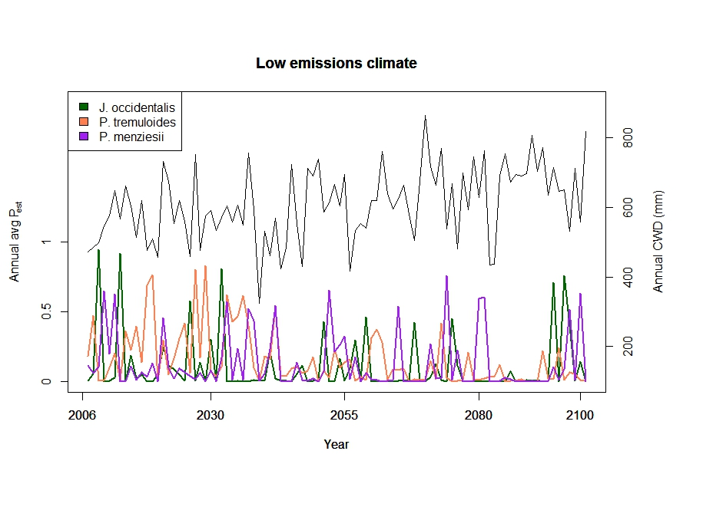

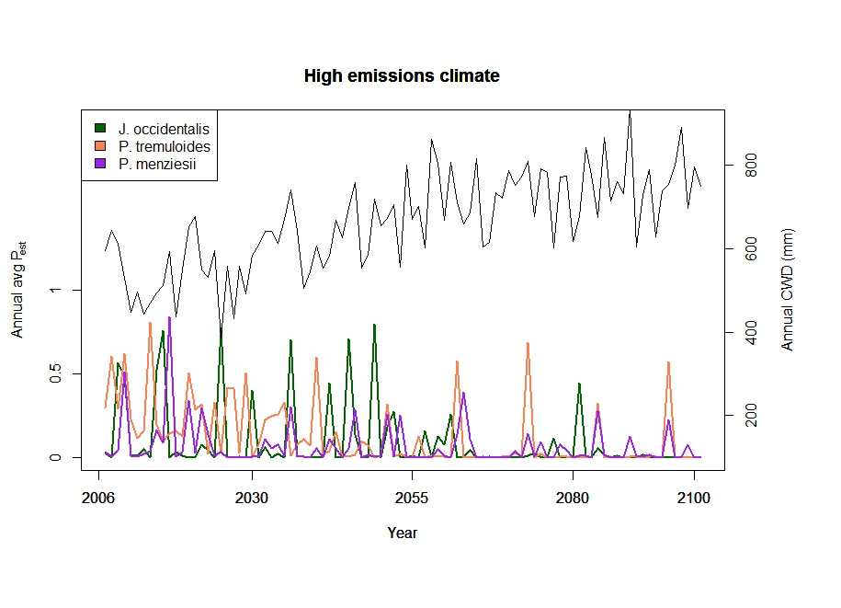

**Area occupied by tree species:** The area occupied by aspen increased modestly under low emissions and declined under high emissions (Figure Z). The area occupied by Douglas fir increased under both climate scenarios although more under RCP 4.5 (Figure Z).

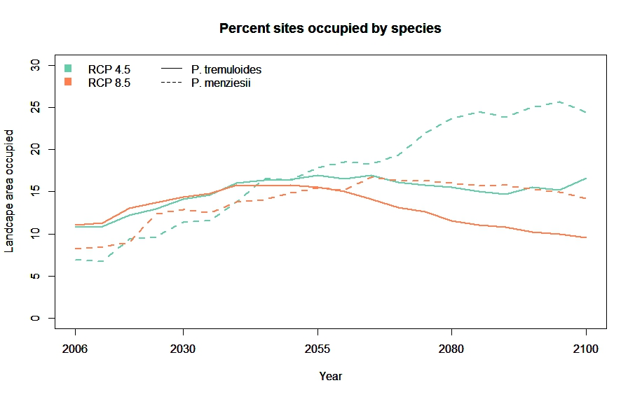

**Aspen persistence:** Of the areas occupied by aspen, 85% was episodic (15% permanent) under low emissions vs. 82% under high emissions. Both climate scenarios resulted in similar distributions of persistence with a modal duration of 70 years (Figure AA). However, many more cells persisted under low emissions than high emissions, except at durations > 80 years. There is a particular spike in 15 year persistence durations for low emissions.

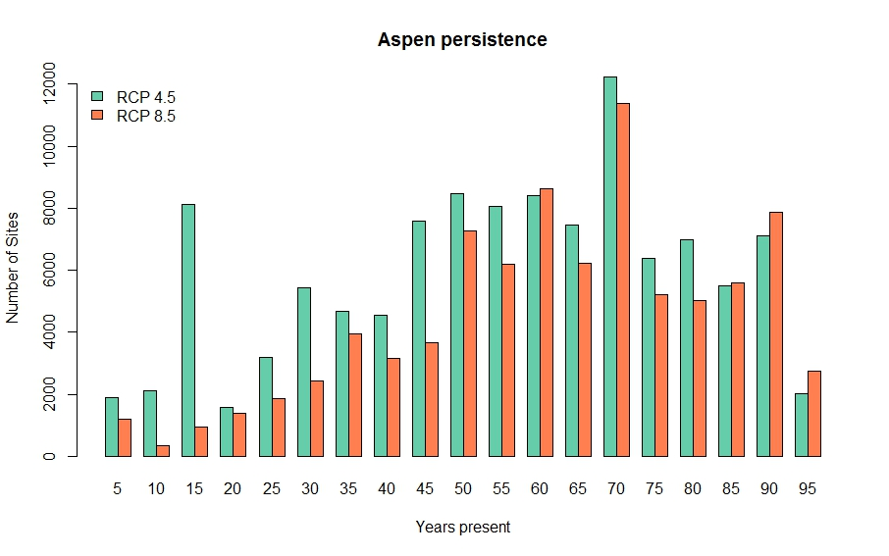

**7. ANALYSIS AND FINDINGS** [essentially this is equivalent to discussion of findings]

7.2.*Post fire aspen regeneration*

Our findings of higher aspen densities with higher precipitation occurring during winter months supports our initial hypothesis. Aspen is not drought-tolerant (Lieffers et al. 2001) and relies on adequate soil moisture to remain productive throughout the growing season….…[Discussion coming]

*7.3 Forecast aspen distributions*

These results indicate that under climate scenarios, only occasional establishment can create patches that persist for long periods in snowbanks and other favorable ecoregions. Under the low emissions climate, there is additional establishment in unfavorable ecoregions that is subsequently lost to climate-induced mortality, generated more short-lived patches of aspen. However, aspen regeneration becomes more infrequent with time under high emissions and long-term persistence will be dictated by the balance between regeneration and mortality.

**8. CONCLUSIONS AND RECOMMENDATIONS**

*8.2 Post fire aspen regeneration*

The findings of this component of the project are critical for managing aspen in light of future projected climate and fire regime changes across the western United States. By the mid-21st century, average fire seasons are expected to match or exceed the largest fire years on record and drought is also expected to increase in the future (Westerling et al. 2011), with the combined effects of increased fire and drought potentially resulting in substantial shifts in forest communities (as suggested by Dobrowski et al. 2015). For instance, aspen are projected to potentially migrate upslope, with suitable habitat predicted to shift 750 m upward in elevation by the end of the 21st century (Rehfeldt et al. 2009).

We were successful in addressing Objective 2 and all tasks were completed as outlined in the original proposal, with the exception of ….[explanation of what didn’t work coming]

**9. MANAGEMENT APPLICATIONS AND PRODUCTS**

*9.2* *Post fire aspen regeneration*

To complete this aspect of the project, we collaborated with managers across several US National Forests and US Bureau of Land Management districts. With each manager that we worked with, we provided the project proposal and initiated discussions about how our project results might best benefit management objects. Table X provides an overview of the key managers that we worked with, although the list of collaborators is much higher when including additional people that were apprised of, and contributed to, this project. We will send our final report to all stakeholders we worked with during this project.

Our findings of the mechanisms impacting post-fire aspen regeneration can be used by managers in several ways. Understanding how aspen respond following fire will provide managers a more comprehensive understanding of how projected future changes may impact aspen conservation and persistence. Additionally, managers can use our findings …[coming].

**10. OUTREACH**

**LITERATURE CITED**